Patterns in Practice: Cultures of AI

Episode 3: Tom Marshman

People

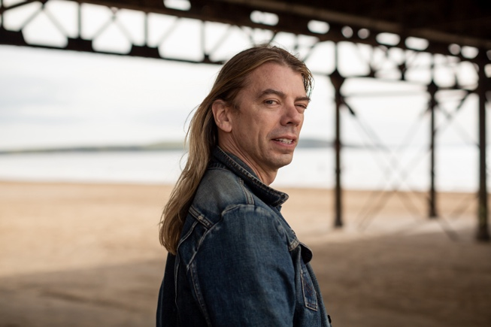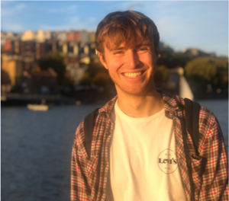

**Tom Marshman**

**Samborne Bush (host)**

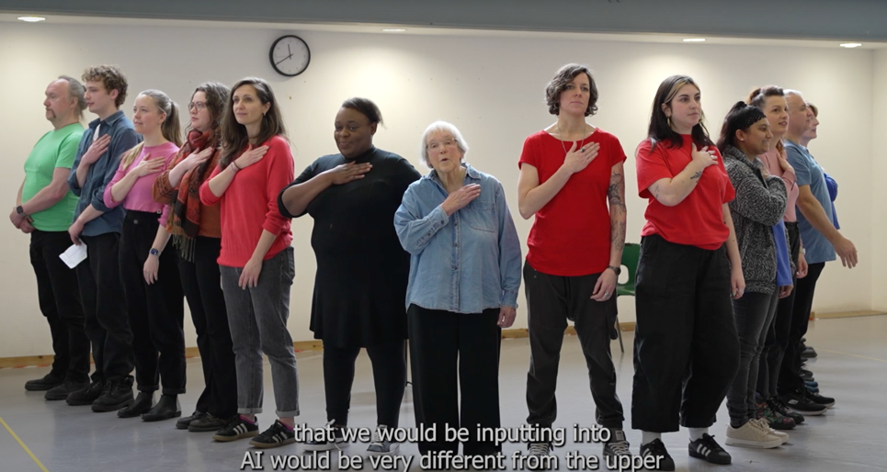

**Bristol Old Vic Adult Company Spring 2024**

Transcript

**Distorted, electronic voice (adult company member):** Could you please provide me with your name? And I'll do my best to share information about its origins.

*Introductory music*

**Samborne:** Hello welcome to back to Patterns in Practice: Cultures of AI.

In today’s episode I’m going to be talking to dramatist, actor and creator Tom Marshman about his work around theatre and archives, his move towards working with AI in a dramatic setting, and all about the adult company workshop series he put together in collaboration with Patterns in Practice.

Our conversation spans Ada Lovelace, convening drama workshops, and how our unruly personal stories are told in the era of AI but before we launch into our conversation, here’s a few questions to think through…

*Musical interlude*

**Tom Marshman:** So I want you to think of your name…

Have you got a chosen name?

How do you feel about your name?

Does it speak to your cultural history?

Do people get your name wrong and how does that make you feel?

What is the story of your name?

*Musical interlude*

**Samborne:** First things first, can you introduce yourself and tell us a little bit about what you do?

**Tom:** So my name is Tom Marshman. I'm an artist, a theatre maker, and a writer. I'm based in Bristol, and I have been making work for about 25 years, really.

So a lot of the work that I make, certainly within the last sort of 15 years, I suppose, is looking at sort of hidden histories, particularly through an LGBT lens or queer frame around things and so quite often I work in archives or in museums trying to find those queer stories, shining a light on them and I guess sort of bringing a new audience to them

And there's something about for me getting people that are living today, so queer people living today, seeing their own stories reflected back in history, it feels quite an important thing to be doing because I think the history that we're taught is quite different and excludes a lot of those stories. So my work I think asks those kind of questions around histories and the narratives that were taught.

**Samborne:** I wonder if you could give us a couple of examples of these sort of archival works that you've done?

**Tom Marshman:** I made a show called A Haunted Existence, which was about a young man that was arrested on a train in the late 1950s. And so, this was a time when homosexuality was illegal.

So, this man was arrested and the police questioned him. And in the questioning, he revealed 18 men that he'd met and had sex with. And then consequently, all these other men were questioned and some of them were arrested, some of them were given sort of chemical therapies that would try to erase them of this perceived illness.

And I suppose I was interested in this story because a lot of these men were kind of from working-class backgrounds, so it was quite difficult to trace any kind of story that belonged to them. Maybe some of them didn't even write at that time, so I couldn't find a lot of them even on census reports.

But this one particular man, I found his story in a passenger ship emigrating to Australia and I found out about his partner that his partner was a chairman of the bowling club in Sydney. So I kind of I became a bit of a detective in that process really and in doing so it spoke to the thing really that I'm talking about which is about what stories we’re told.

Another show that I made was about a trans woman living in Newcastle, called Jenny Moore, or she gave herself that name sometimes. She changed her name quite a lot.

And we only really know about Jenny through her criminal actions, because those are the things that are recorded. So in newspaper articles about, and she was involved in various crimes from kind of petty pickpocketing to shoplifting to running a house of ill repute.

And I think that story is quite sort of typical within queer peoples, within what you get given queer people's lives is that their criminal activity is the only thing that remains. So it's not really a- it doesn't give you a full picture of people's lives.

So I think that what I was trying to do in that show is read between their lines. And with this, with these works that I make, I have this kind of methodology that I've developed through a kind of mashup of various academics, including Rebecca Schneider, which I've worked on with a historian called Jeannie Sinclair.

And the basic idea is that you look at what the bones of a story is, what the ghosts of a story are and what the flesh is.

So the bones are the facts like maybe their birth reports or where they lived and dates that sort of thing. You could say that the ghosts are like what is missing, so where are the stories that we can't find?

And then the flesh is, are there sort of contextual stories that might speak to that, what was happening during that time that we can kind of like learn from in order to try and create a bigger picture.

**Samborne:** And so this takes us onto your most recent work, running a 10 week workshop series with the adult company at Bristol Old Vic, in collaboration with Patterns and Practice, of course. So briefly, what has this involved?

**Tom:** So I was invited by the engagement team at Bristol Old Vic to run their spring term adult company class, which is something that they run quite a lot. So this was the spring term. So they always choose different artists to lead those sessions. And I think they wanted me to present something- I mean, I work a lot with personal stories, verbatim, you know, things that are found in archives.

I think they were thinking that that's kind of the project that I might end up delivering, which is quite sort of like something that's quite known to me, I suppose. When they invited me, I kind of wanted to put an extra something onto it really, so that I would be coming into a process of like, not really knowing where I was going, but kind of being fine with that.

So I kind of came up with the idea of like, working with personal stories and AI because it sort of felt like what AI was currently offering us is quite a sort of binary option. It doesn't really feel like it has space for the kind of unruliness of people's lives, the messiness or the queerness or whatever that is.

So I wanted to sprinkle both the AI into the personal and the personal into the AI.

**Samborne:** And as you move towards the topic of artificial intelligence, I wonder if you could tell us a little bit about what your inspirations were and what gave you ideas as a creative into this topic?

**Tom:** Yeah, so I think that I was really making a show that kind of explored what AI currently is for us, but I was also using the tools of AI to make it. I was looking at other artists that work with AI as inspiration really, and I came across a really brilliant book, which is a series of essays by Jeanette Winterson.

It's called 12 Bytes, and the first chapter is called ‘Lovelace Actually’ and it kind of traces the beginning of AI to Ada Lovelace, who was Byron the poet's daughter who kind of by some series of situations that she found herself in, got into, really was into maths and got into creating a kind of what we think of as the first computer which was kind of...steampunk like machine I suppose that used hole punching to create rhythms I suppose.

She wrote quite a lot and quite extensively in diaries and added notes to the reports that were about the machine that was created which were much more rich than anything had been written about before but when you look at those writings she sees how things could bein the future in terms of a machine being able to think for itself and develop new things that are out of the realm of what we can do as humans right now.

And it aligns with what really excites me because her story is kind of forgotten about or slightly hidden really.

It's a story about a woman in a man's world and also it just really appealed to me that those notes were kind of ignored for such a long time until Alan Turing picked them up, who was obviously we know was a gay man and was chemically castrated, which was what, you know, it speaks to the story of haunted existence, which I was talking about as one of the shows that I made.

So right at the heart of AI is a woman in a man's world and a queer man. And I sort of felt like I wanted to work with those people**…**to summon them somehow.

**Samborne:** So how did these various sources of ideas play out in the workshops that you did?

**Tom:** I think that adult company at Bristol Old Vic were just brilliant for me because I would come in and say, I don't know what I'm doing, I've never done this before, it's exploratory, you know, it's research. So they just kind of, I felt held by that group really.

And I think there was something about like working out who I was within that role. So I wasn't a director, I was kind of a facilitator of those ideas really. And I have a kind of repertoire of little workshop exercises that I do in kind of group situations like that. And one of them is like creating like a micro performance about like, ‘what is the story of your name?’ which is just a very loose invitation for people to think about themselves, their own stories, their biography, their memoir, their, you know, what makes them them.

And they created these kind of like very short micro performances over the week and then presented them to the group. And what they had in them was just this real quality of feeling, or, you know, feeling very different from everyone else, feeling a bit of an outsider, their specificness of their cultural identities or their age and experience.

So these performances had this kind of fragileness or this kind of vulnerability or this unruliness which I felt like sat somewhere in opposition with this kind of knownness that AI was putting out there. So I then invited them to use these micro performances, the material they’d made, to somehow feed that into the AI, to get a conversation running with AI.

So often we were working with ChatGPT, but some of the group worked with other platforms like Snapchat or other things. But I was deliberately quite vague with the adult company because I wanted it to be really open to interpretation. So some people kind of created these kind of duets that were a script almost between the AI themselves which questioned, which they then questioned the AI.

So like, “why are you talking about all of these people that have the same family name as me, a men, you know, where are the females with my surname?” And AI would be quite AI-ish in the way that it says something like, you know, “oh yeah, there's your very right to point that out and I appreciate your, your viewpoint and let's try and focus on something else now”, you know, like the AI does.

And we performed that AI-ness within this kind of 20 minute sharing that was a Bristol Old event.

**Adult company audio clip:** Could you please provide me with your name and I'll do my best to share information about its origins?

My name is Anna Stacy.

A vibrant tapestry woven from two distinct names Anna, Stacy. It's melodic, reminiscent of the catchy refrain Anna, Anna Bobanna.

The story of my name is that even though Ellie is a common name, hearing it from the people in my life makes me feel special and loved. What's your name?

I don’t have a personal name as I am a machine learning model, is there anything specific you'd like assistance with?

**Tom:** We started with people performing their names. We also performed a sort of version of like the Ada Lovelace story. But I was really trying to work out how I could differentiate the AI persona to the kind of the individual stories, I suppose. And I just felt- I was thinking a lot about the human voice and creating it to be sort of slightly robotic really, so I got a voice transformer and we kind of messed around with that.

And that also sort of allowed us to work with some of the glitches that AI does, looping and repetition and just the general roboticness of the voice.

**Distorted, electronic voice (adult company member):** Could you please provide me with your name? And I'll do my best to share information about its origins.

**Samborne:** From across the workshop series and the showcase, are there any moments that particularly jumped at you and you thought oh wow this is a something I hadn't thought about?

**Tom:** I was really interested in one of the letters that we discovered from Ada Lovelace so her story is kind of quite sad at the end so she gets involved in drug addiction and gambling and she's still writing about the computer but with a kind of slightly removed so there's a slight madness in her writing I suppose and she's talking about fairies

And it's very hard to decipher but I felt like it was really beautifully poetic and I think that what is interesting about Ada Lovelace's story is there's a real sense of tension between the poetics which is like what her her father represents so Byron and this kind of they had a bad relationship and then her kind of movement into mathematics.

One members of the group decided that as we were working on the translating this letter that was quite hard to decipher, maybe we should put it into AI to see like what AI would make of it. And it did make it more comprehensible.

And that was how we finished the sharing really with this letter from Ada and giving her the last word I suppose. So this was read by the whole company in sort of these tiny little bite-sized chunks.

**Tom Marshman and the adult company together:**

Labour is its own reward.

My kingdom is not to be a temporal one.

Thank heavens.

I have taken it into my head, or lived in time and circumstances, calculated into my head to deal with the sword, poison, and intrigue in the place of X, Y and Z.

The brain of mine, something more than mortal.

As time will show, the devil is in it, if I have not sucked out some of the lifeblood from the mysteries of the universe.

No one knows what almost awful energy lies yet undeveloped in this wiry little system of mine.

I say awful because you can imagine what it might be under different circumstances.

And I have noted that some of the ideas could lead down a destructive path, unless I have managed to suck out some of the mysteries of the machine.

The power of my invention is, and yet, untold. And that is a terrible beauty within.

Heart emoji.

Hashtag maths rules.

Hashtag women in tech.

Hashtag women rule.

Hashtag women in power.

Hashtag if it wasn't for me there wouldn't be any hashtags.

Your fairy forever.

Ada Lovelace

**Samborne:** And were those final ones, was that AI coming up with-?

**Tom:** No, we added the hashtags, *laughs*

**Samborne:** How did you use the Patterns in Practice research and infuse some of the ideas from this project into your drama workshops?

**Tom:** We talked initially about kind of how we felt about AI and I used the research to kind of like chair that kind of conversation.

And we looked at some of the ideas around how there's a kind of human-machine collaboration going on and what that would look like going forward within the work that we were creating together.

And we talked about that kind of like deficit of surprise. Some of the group were women, older women perhaps, that have been dealing with misogyny for all of their lives. So, there was this kind of like, well, it's not really that surprising that AI is going to come up with something that feels like intrinsically misogynistic, or is less centred around a woman's experience.

And that was something that felt when we were at the beginning of the journey, we had that idea that that's where we might end up. And we certainly were dealt that card quite a lot.

**Samborne:** So do you think this workshop series, Working with AI and Working with Patterns in Practice, has influenced you at all? Do you think you'll be looking to explore these ideas in future?

**Tom:** Yeah, I mean I think that we are only at the beginning of this journey with AI in terms of being a creative practitioner and responding to that.

I think that I've already started working with AI so sometimes as an artist you're like really struggling to find something that feels like, I know what the style of this thing is for this moment, but I don't really know how to do it right yet. So I just put a holding thing in. And actually I've used ChatGPT to create like a holding moment for that piece until I kind of work out what the rest is because sometimes when you're making a show, it's a bit like sort of creating a painting where you've got all these different elements at play.

And as an artist, it's really important to be reflecting what people are thinking about at the moment. I think people are thinking a lot about AI, and I would just want to be part of that conversation, so I definitely want to continue exploring what this means to me and how society are responding to it.

And I think when we're talking about archives, you have to see them as kind of not neutral spaces, that they are, or have been at least, run by rich, white, powerful cis men. So they have a way of interpreting kind of anything that's given to a collection.

And when AI was developed, I'm pretty sure that people that have like challenging lives or unruly lives or queer lives or people that are affected with disabilities or maybe even people of colour like, their stories are less present within that so I feel like as an artist my responsibility is kind of to say what about us you know? And we’ll continue to do so I think.

What I feel like I've learned and continue to learn is just more about humanity, what it feels like to be a human, because what we've been working with is something that is very unhuman, which teaches you so much more about being human.

*Musical Interlude*

**Samborne:** If you’re interested in finding out more about Tom’s work, you can check out our website, search Patterns in Practice, where there is a link to a video all about the adult company workshops and to Tom’s website.

My name is Samborne Bush, thank you for listening, we will see you soon.

*End.*